To use your personal Google Gmail address within Maestro to send to your patients, a few changes need to be made within your Google Gmail account for this to be possible.

Things you will need:
- Access to your Gmail account. Specifically, your Username and Password.
- The cell phone you have linked to your Gmail account already, or one that you would like to utilize going forward.
Per Google security measures, these steps must be followed within your Gmail account or Gmail will not work within Maestro. These changes are not at our control and are subject to change at Googles discretion.
There are three parts to this process, two of which will happen in Google, one in Maestro.
Part One:
- Go to myaccount.google.com/security. You will have to be logged in to access this page, but if you are not already, it will prompt you to do so. Please be sure to log into the account you wish to use for emailing.
- Scroll down until to see “Signing into Google”.
- Select the “2-Step Verification” option
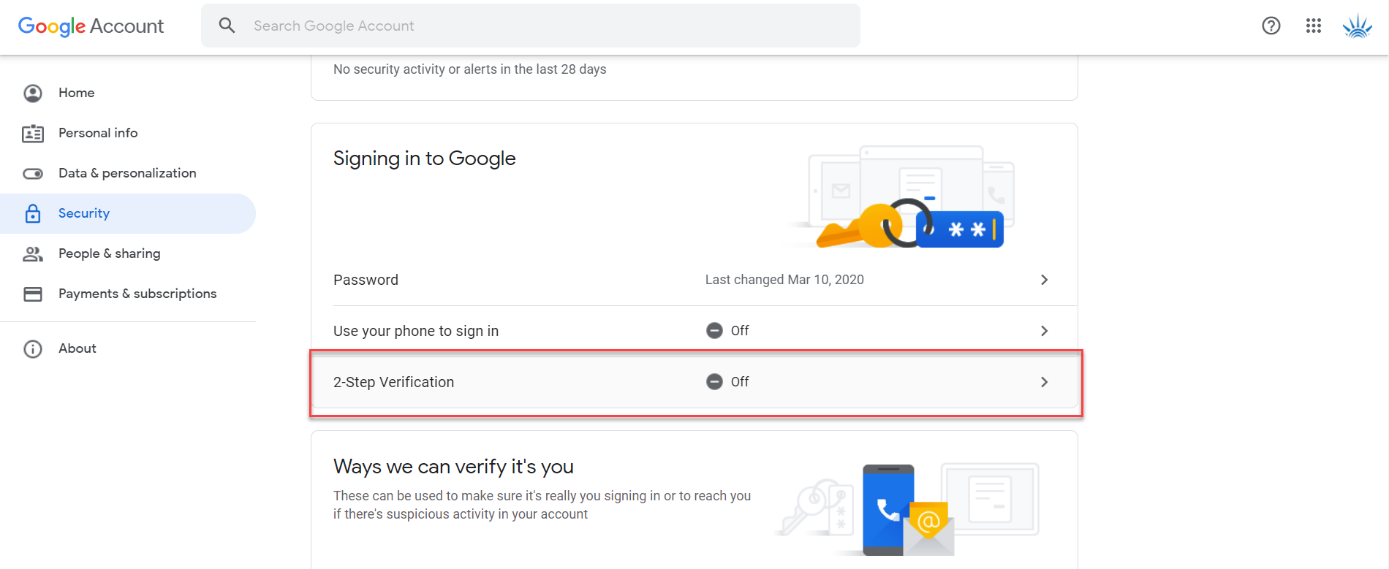
- Select “Get Started”
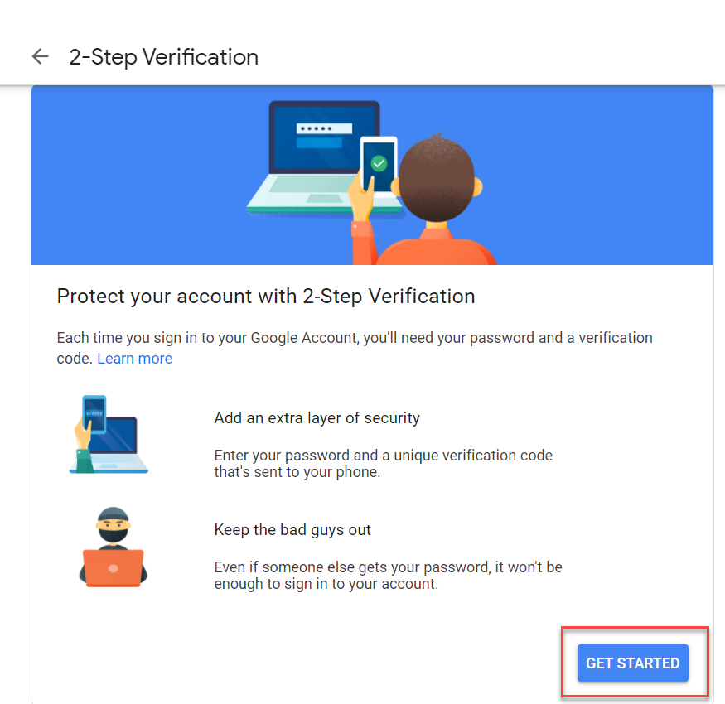
- Enter your password to verify you are you
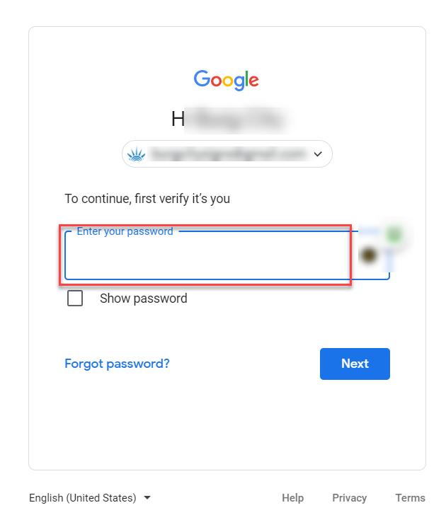
- Select the “show more options” option.
- Select the “Text message or voice call” option.
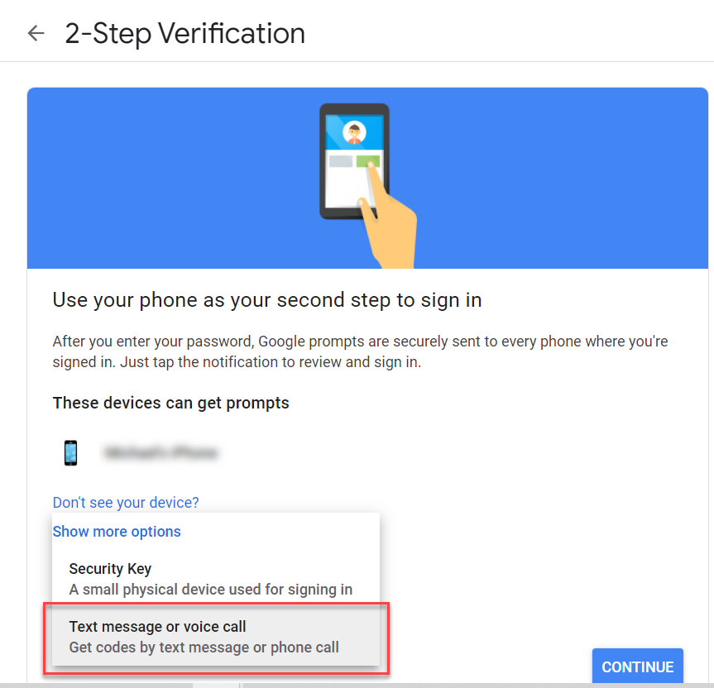
- Enter your phone number and select text message. We recommend you utilize the text messaging as it is far easier.
- Select “Turn On”
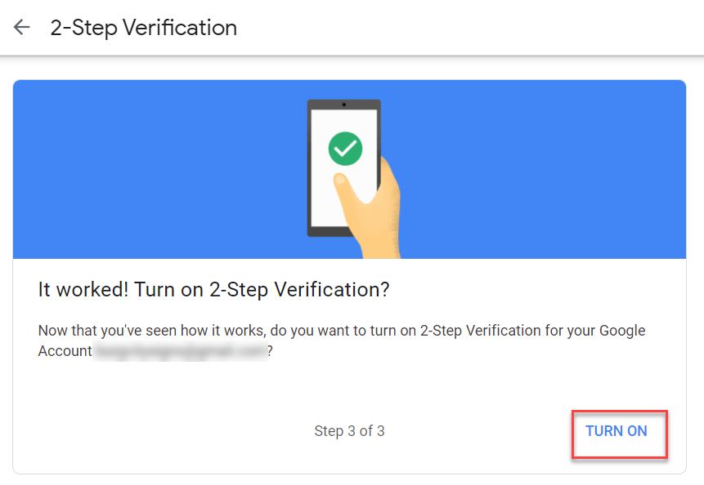

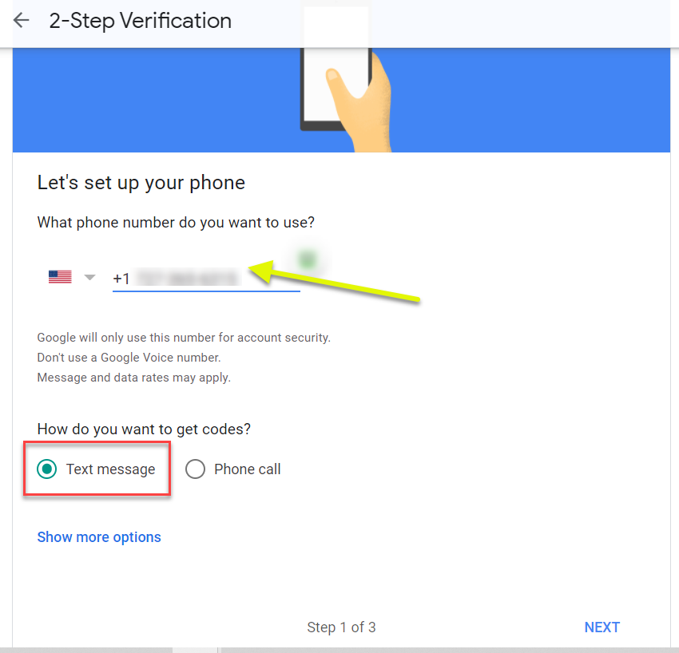
- Finally, select “Turn On”

Part Two:
- Return to myaccount.google.com/security if you are not already there.
- Scroll down until to see “Signing into Google”.
- Select the “App passwords” option.
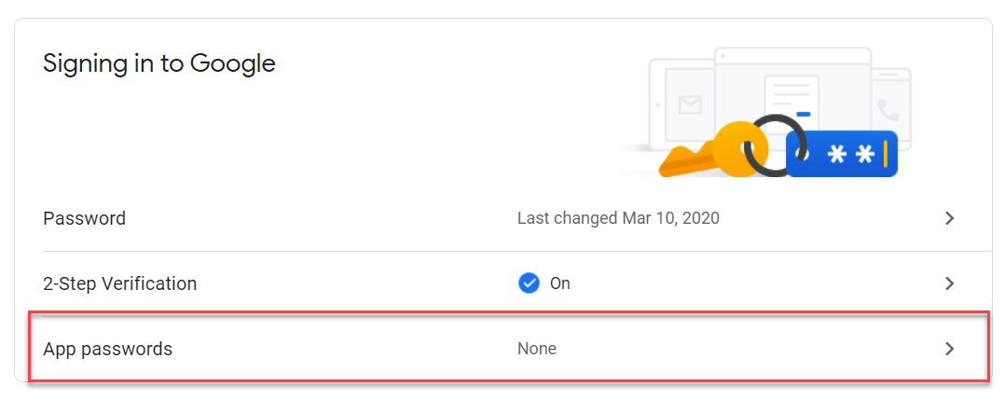
- Under the Select App dropdown, select “Other (Custom Name)”
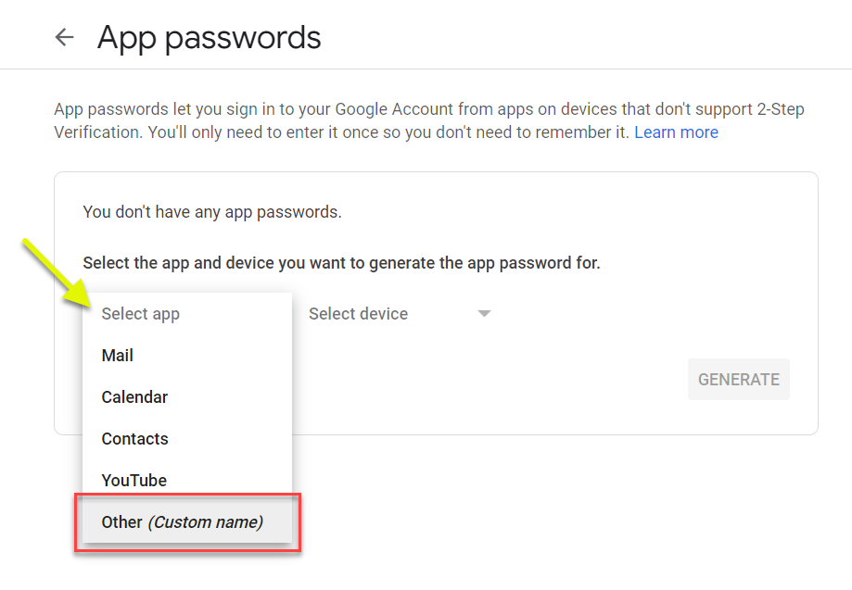
- Enter Maestro as the custom name and then select “Generate”.
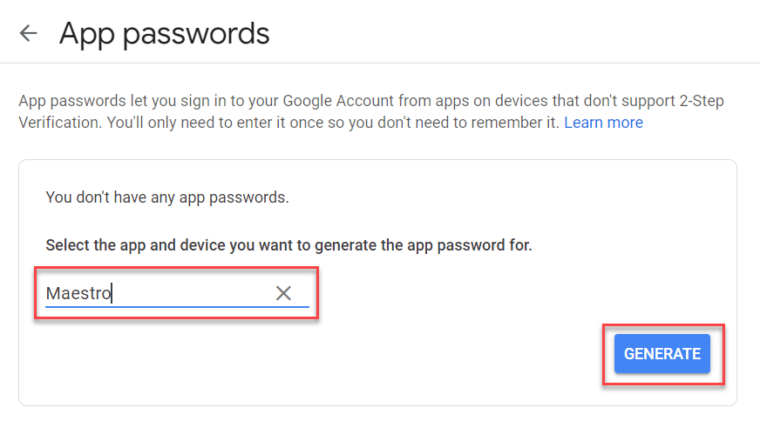
- Stop here. This step is very important as you will not see this password again. Although the screen tells you not to write it down, we recommend you write it down now. Remember that passwords are case sensitive, so write it down exactly how it is shown. Spaces are not needed. (Note that the password in the picture below is not valid, do not use)
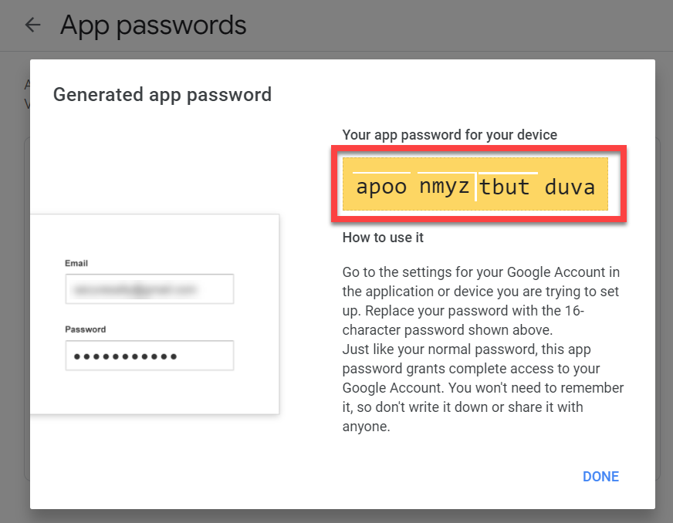
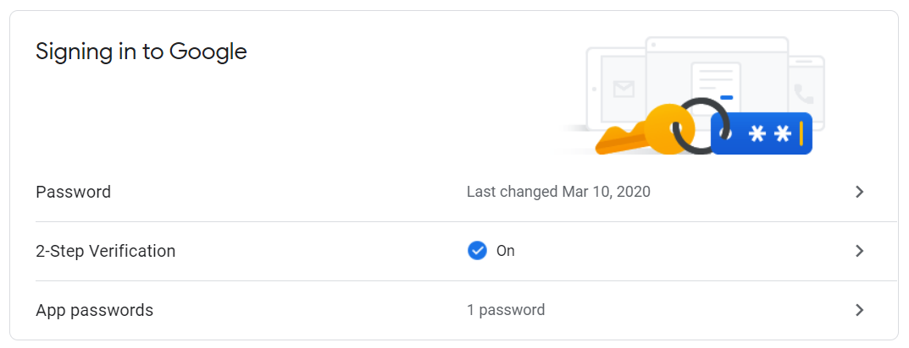
Part Three:
To use Gmail in Maestro, the email account you use in Maestro must be a Gmail address. You can check this by going to Setup and Organization.
- In Maestro, select “Setup” on the top menu bar.
- Select “Settings” on the bottom menu bar.
- Select “Settings 2” just under the top menu bar.
- Toggle the “Allow Edits” button from Off to On
- Make sure that the radio button for “Use Your Gmail Account to Send eMail” is filled, then enter the 16-digit password you received from Google in step 2.
- Select “Test” and follow-on screen prompts.
